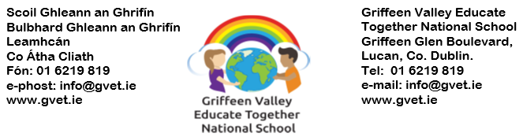
The PTA Annual General Meeting (AGM)
Dear Parents and Guardians,
We, the PTA would like to invite you to attend our AGM to be held 25th October 2023. The meeting will start at 7pm and will be held in the school with an option to attend over zoom also.
The PTA plays a vital role in the school community and all parents, as members of the PTA are invited to support the AGM. This is your chance to hear and see how the funds you have helped to raise have been used for the benefit of the children at our school.
The AGM is also an opportunity for you to elect the PTA committee, who represent the parent body throughout the coming year. Nominations should be sent in advance of the AGM for anyone wishing to stand as an officer or an ordinary committee member for the first time. Please email info@gvet.ie to inform the principal of your nomination. Existing committee members who wish to stand for re-election do not have to be nominated again but should inform the outgoing committee of their intention to stay in their role. Any parent or guardian of a child in the school can be nominated, provided it is with their knowledge and consent.
We understand that people may not be able to join the committee but might like to help out during the year, so the PTA have decided to create a volunteer register. A WhatsApp group will be created with volunteers and any events that we need help with will be added to the group. These could be things like 6th class graduation, Halloween disco, school tours, sponsor walk etc. If you wish to be included in the volunteer register, please send an email with your name and phone number to chairpersonPTA@gvet.ie
Agenda for the Griffeen Valley PTA AGM:
- Welcome
- Ratify Minutes of the last meeting
- Chairperson Presentation on the activities
- Treasurer Presentation on PTA finances
- Talk on parent participation in PTA activities
- Principal/Board of management address
- Election of the new Griffeen Valley PTA Committee
- Close Meeting
Kind Regards
Griffeen Valley PTA Committee

